BizHse 2027

Welcome to BizHse2027!

The split into different sections is starting to take effect with a great tussle guaranteed for 2027.

With Adam & Eve Dickinson from Ray White along with New World Whangaparaoa coming on board again as our major Club Partners for this event it’s going to be an exciting time for us all.

At the end of last years event we asked for confirmation you would be returning and at the same time we asked for some comments – Because we listen, the food has changed, as has the music, but the beer will still be cold and the outlook is….. fun!

The confirmation for returning was again almost unanimous and with teams waiting in the wings we do need a timely confirmation that you’ll be ready to go. – So don’t miss out!
Please confirm (either yay or nay) by 30th November to avoid disappointment – This by completion of the Entry Form or email cancelling.

Due to a National Bowls Competition we have had to modify the dates, so please note carefully as we need to have a small break in the middle of BizHse for 2027.

Playing Schedule:
Dates: |  |  | Start: | Finish: | Note:
13 | January | Wednesday | 6:00 pm | 8:00 pm | Kick-Off !
20 | January | Wednesday | 6:00 pm | 8:00 pm
27 | January | Wednesday | 6:00 pm | 8:00 pm
3 | February | Wednesday | 6:00 pm | 8:00 pm
10 | February | Wednesday | 6:00 pm | 8:00 pm
17 | February | Wednesday |  |  | No Play
24 | February | Wednesday |  |  | No Play
3 | March | Wednesday | 6:00 pm | 8:00 pm
10 | March | Wednesday | 6:00 pm | 8:00 pm
17 | March | Wednesday | 6:00 pm | 8:00 pm
19 | March | Friday | 6:00 pm | Late ! | Finals Night & Prize-Giving

Convenor:
Your contact for queries is our Commercial Manager:
Andy Dorrance
cm@manlybowlingclub.co.nz
022 508 2650
Club Ph: 09 424 7396

Bar & Liquor Licensing Laws:
The ever-popular Drinks card will be available again. 12 Drinks for $96 (Purchase at front desk or bar). The cards can be used for Tap beer, bottled beer or a glass of wine.

Our full range still includes Tap Beer, Bottle Beer (incl Non/low-alcoholic, low carb) RTD’s and wine by the glass or bottle. Spirits are available too along with soft drinks, peanuts, chips etc – quite a long list of offerings.

The alcohol licensing laws prohibit the bringing in of any form of alcohol. Team captains please make your team very aware of the following:
- All team members must be registered as Social Members of the Manly Bowling Club.
- Strictly No “BYO”.
- No alcohol may be taken from the premises.

Any person breaking these laws will be excluded from the competition and asked to leave without refund or discussion.

Membership:
On registration a player will be registered as a Social Member which (for the first 4 players) is included in the entry fee. Further players must be registered before play with a Social Membership Fee paid of $5.
The Social Membership entitles the members to enjoy the facilities of the club for the entire 2027 calendar year.
Registration on the app TeamReach is confirmation of social membership.

Fee Schedule:
Team | 4 x Players | $200 | Includes Social Membership for 2027
Individual |  | $5 | Replacement / Substitute Players (Soc. Mem. For 2027)

Payment of the Team Entry Fee is to be made by 1st December 2026.
Bank Account: KIWIBANK 38-901-90630353-00. Reference: BizHse

Cancellation:
Should any night be rained off we will endeavour to complete the effected round on the Friday (ie 2 days later) as first option or another Friday, dependent on weather.
Any Cancellation will be posted on the Website and Facebook along with TeamReach.

TeamReach:
The TeamReach app will again be the main contact for cancellations and updates so do ensure your team members are all registered on the app. (Invites will be sent once registration is completed. (Don’t forget to post pics too!)
Download TeamReach for IOS/Android/PC. Code: BIZHSE2027

Bowls:
We do have a limited number of spare sets of Bowls and can supply them if required. Please ensure that anyone requiring Bowls is noted on the entry form in order to have them put aside for your use.

Raffles:
There’ll be the usual Meat Raffles and of course the ever popular “Duck Race”.
Winnings will be split 50/50 between the winner and the club. The meat raffles are $2 a ticket and the duck race is $5ea a ticket.
Because we are a community club we will again have a Duck Race for the kids.

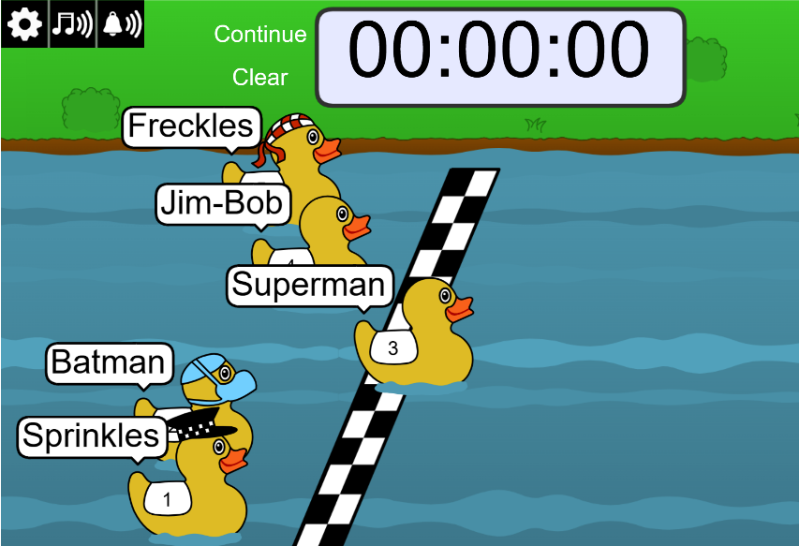

Etiquette:
Usual commonsense manners of course, but please do note:
No Heels (Flat soled shoes, socks or bare feet only)
No Smoking or Vaping (There are two designated areas outside the club for smoking)
No Drinking on the green (Have a glass at each end!)
No Eating on the green
(Alcohol may be consumed on the surrounds).

Rules:
No “up-shots” or “Driving” (We define this as a delivery which is delivered at a pace far greater than required to reach the Jack and is designed to radically disrupt the head).
If the Jack goes out of the rink it is placed on the 2 metre “T”.
If the Jack goes into the ditch, remaining inside rink, it stays in the ditch.
One Bowling Club (any club) member only per team. They must only play position “Two”
Coin toss to start game. Winner bowls the Jack and 1st Bowl.
Children under 12 are more than welcome but they must be supervised at all times and are not allowed on the Greens.

Grass Green:
Due to number of teams, we are playing on the Grass Green again this year. The cost of maintaining this piece of “Hallowed turf” is extraordinary and we do ask for special consideration in helping keep it in pristine condition.

Running Jack Café:
We now have a full kitchen up and running. Offerings along with the sausage sizzle and Ice Creams will be hot chips, toasties and burgers meaning the family is now catered for and helps make for a great night.

Registration:
Registration can be completed using either the attached form or on-line at:
Social Bowls Events | Business House and Twilight Bowls | Manly Bowling Club , https://www.manlybowlingclub.co.nz/social-bowls/
Please complete and return it with Entry Form. (This form may be copied, printed with extra names or the form available at the club may be used.)

Entry Form - BizHse 2026

Team Name: ………………………………………………………………………………………………………

Main Contact: Name: ………………………………………………………………………………………………………

Ph: ………………………………………………………………………………………………………

Email: ………………………………………………………………………………………………………

Players Details:
Name: | Ph: | Email: | Bowls Required (Y/N)

Please ensure a Social Membership form is completed for each player

Social Membership Application – Biz Hse

Name: Name:
Address: Address:

Phone: Phone:
Email: Email:

Name: Name:
Address: Address:

Phone: Phone:
Email: Email:

I/We agree to, and will abide by, the Rules, Core Values and Terms and Conditions of the Manly Bowling Club

I/We agree to receive information on Social Events at Manly Bowling Club

Signed: Signed: Signed Signed:

…………………………. …………………………. …………………………. ………………………….

Dated: Dated: Dated: Dated:

…………………………. …………………………. …………………………. ………………………….

